Conversa Solutions Expands Ensemble MDM to Include
Robust Apple Management Capabilities

Ensemble’s new feature set delivers seamless device management for iOS, and Apple hardware, empowering businesses with a unified solution for multi-platform environments.

OAK BROOK, ILLINOIS [JANUARY 7, 2025]

Conversa Solutions, a leader in enterprise mobility solutions, proudly announces the expansion of Ensemble MDM to include comprehensive management capabilities for Apple devices. This enhancement enables organizations to seamlessly deploy, manage, and secure their iOS alongside Android and other mobile hardware within a single, unified platform.

As enterprises adopt diverse device ecosystems to drive productivity, the need for efficient and integrated management solutions has never been greater. Ensemble MDM now empowers IT teams to streamline operations with simplified provisioning and enhanced security controls for Apple devices. Key features include zero-touch deployment with Apple Business Manager, device and app configuration, and inventory management.

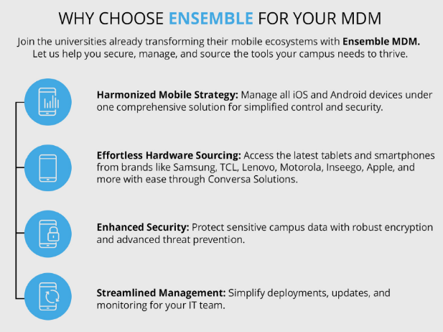
“The addition of Apple management to Ensemble MDM marks a major milestone for our customers,” said Brian Sipe, President of Conversa Solutions. “Businesses today rely on a mix of devices to support their teams, and our expanded capabilities ensure they can manage their entire mobile ecosystem with ease, security, and efficiency. Ensemble MDM delivers the flexibility enterprises need to support their growth while keeping IT processes simple and cost-effective.”

Ensemble MDM’s new Apple-focused features further strengthen Conversa Solutions’ position as a trusted provider of scalable, platform-agnostic mobile device management. By enabling businesses to secure and optimize Apple devices alongside Android and other hardware, organizations can better address the evolving demands of remote and hybrid workforces.

For more information about Ensemble MDM and its new Apple management capabilities, please visit www.ConversaSolutions.com or contact Mike Fleming at m.fleming@vertexwireless.com.

About Conversa Solutions
Conversa Solutions is a leading provider of enterprise mobility solutions, specializing in mobile device management (MDM), hardware sourcing, and IT support. With a commitment to innovation and customer success, Conversa Solutions helps organizations streamline their IT operations, improve security, and enable workforce productivity across any device and platform. For more information on Conversa Solutions follow us on LinkedIn, and YouTube.

Media Contact:
Michael Fleming
Sr. Director, Marketing & Strategic Development
Phone: +1.630.473.0713
m.fleming@vertexwireless.com

